Competitive Analysis

Case Study 1: http://terrycavanaghgames.com/dontlookback/

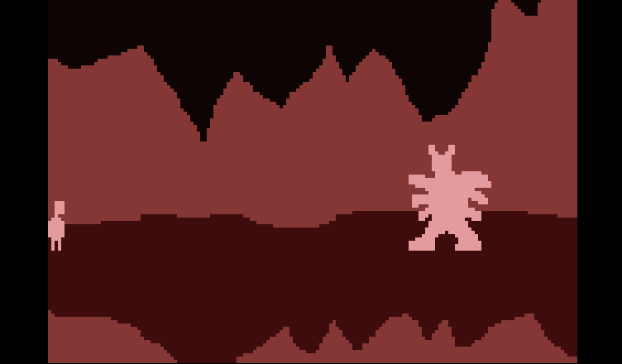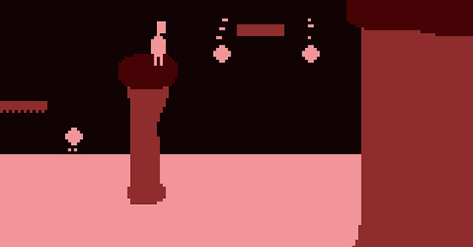
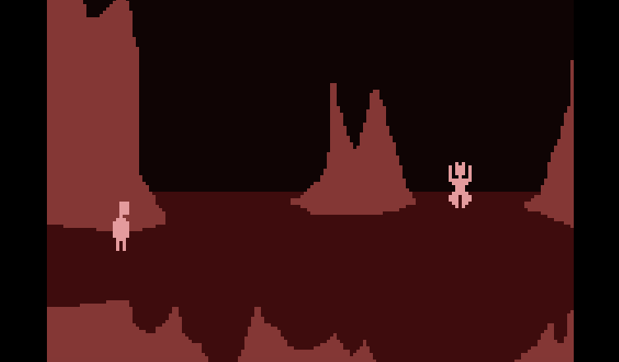

Case Study 2: http://thelettervsixtim.es/

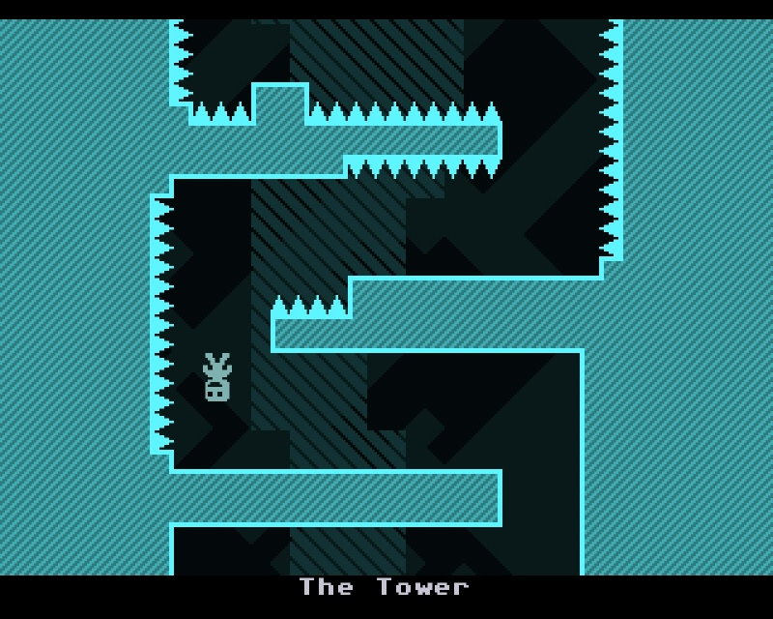
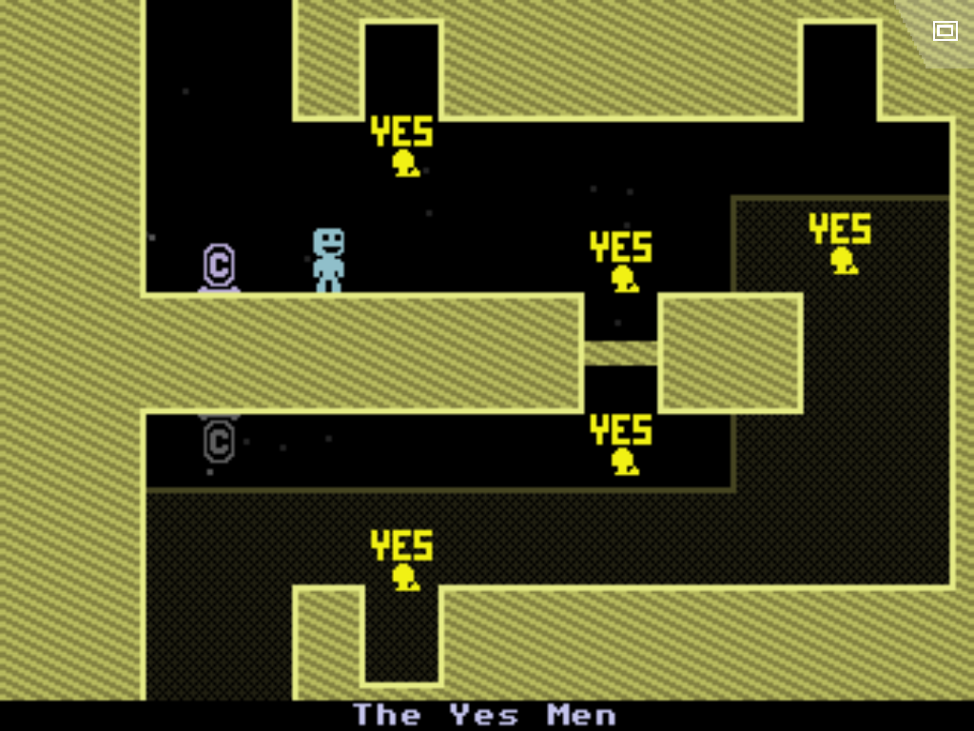
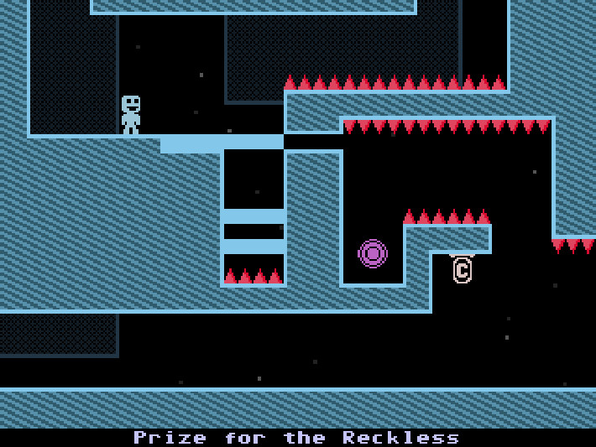

I intend to largely base GON off of case study number one (from now on to be referenced as 'CS1'). The main differences will be the aesthetic of the game, the overall playability, and the overall storyline. CS1 is based off of the greek myth of Orpheus and Eurydice. I intend to include similar themes while not completely ripping off the story arc. CS1 was mainly criticized for its high level of difficult and I intend to curb that in GON. It is unlikely that I will have time to incorporate the low-fi 8 bit soundtrack that really accentuates both CS1 and case study number 2 (from now on to be referenced as 'CS2'). But I will try to add some sound as long as I get the game set in its playability first. CS1 was fighting-based for the first half and puzzle-based for the second half with no physics-based puzzles. CS2 is entirely physics and puzzle based. I intend on striking a more balanced middle ground of all three of those elements (puzzle, fighting, and physics). Overall, I hope my game will be quite reminiscent of Terry Cavanagh's work with my own voice quite apparent in the visuals/storyline.

